

Artificial Intelligence (LAB)
LAB Report 5

Submitted By:
Wajahat Aftab
SU92-BSSEM-S25-002
BSSEM-4A

Submitted To:
Sir. Rasikh Ali

Task 01:
- Trace the Supplied Tree by Hand Using Minimax
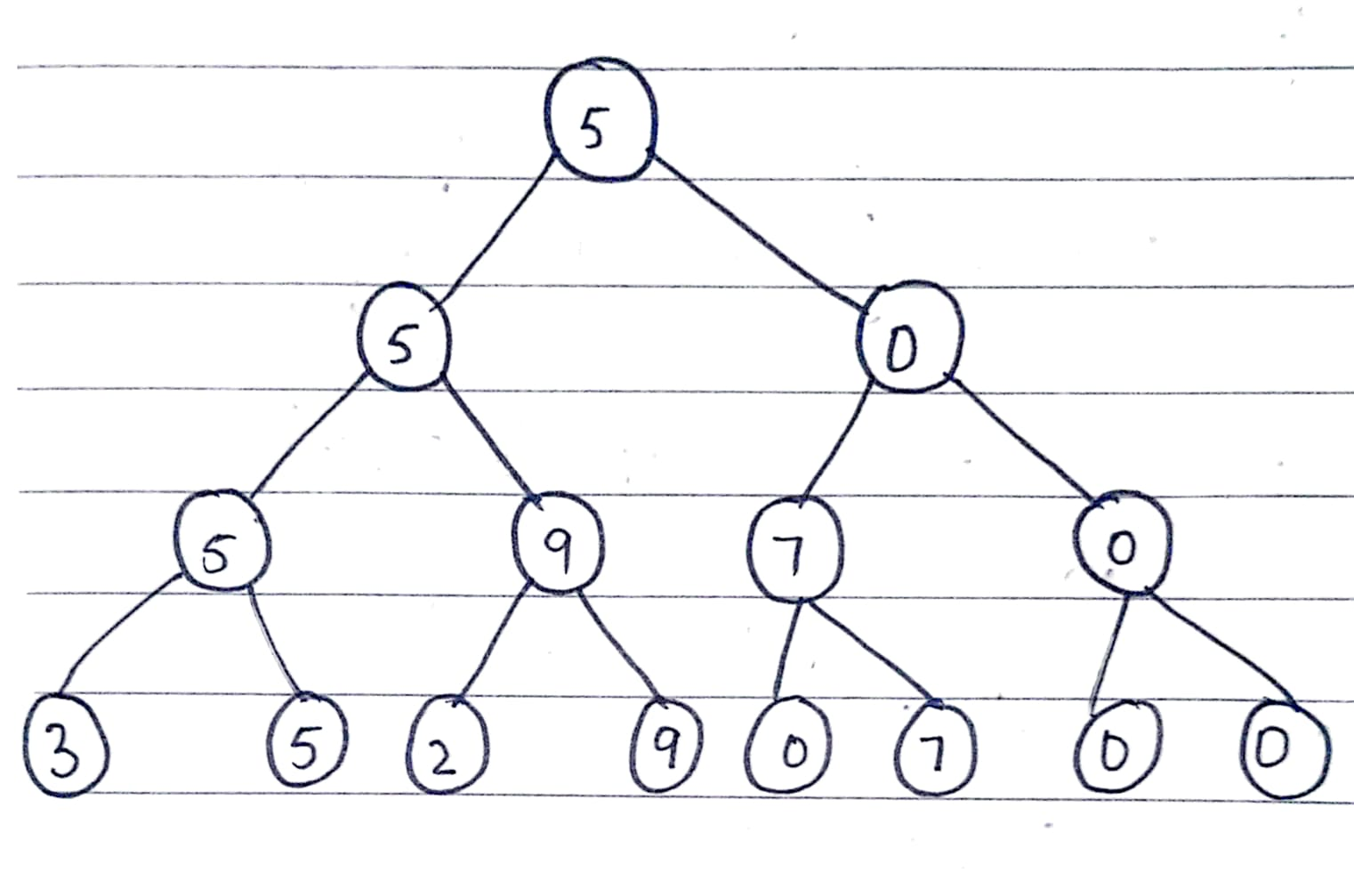

Working:
- Leaf Values:
The leaf values are 3, 5, 2, 9, 0, 7
The code add two zeros to make a complete binary tree
Final leaf score: 3, 5, 2, 9, 0, 7, 0, 0
- MAX Level (Bottom):
MAX selects the highest value from each pair
- Max (3, 5) = 5
- Max (2, 9) = 9
- Max (0, 7) = 7
- Max (0, 0) = 0

- Min Level:
Min selects the lowest value
- Min (5, 9) = 5
- Min (7, 0) = 0
- Root MAX Level:
The root selects the highest value
- Max (5, 0) = 5

- Final Result:
The optimal minimax value is 5
Task 02:
- Add Leaf Evaluation Counter
Working:
A leaf evaluation counter was added to both minimax and Alpha-Beta pruning algorithms
Results:
Algorithm | Optimal value | Leaf evaluation
Minimax | 5 | 8
Alpha-Beta pruning | 5 | 6

Explanation:
Because the minimax algorithm does not prune any branches, it must evaluate all 8 nodes to find the optimal value. In contrast, Alpha-Beta pruning eliminates some branches so it evaluates only 6 leaf nodes. Both algorithms find the same optimal value of 5, but Alpha-Beta pruning requires fewer leaf-node evaluations.
Conclusion:
The Alpha-Beta pruning algorithm is the most efficient to use on this tree as it evaluates fewer leaf nodes.
Task 03:
- Reorder Branches and Observe Pruning
Working:
The leaves were reordered into [ 0, 7, 3, 5, 0, 0, 2, 9] and the minimax and Alpha-Beta pruning algorithms were carried out
Results:
Algorithm | Optimal values | Leaf nodes evaluated
Minimax | 5 | 8
Alpha-Beta Pruning | 5 | 8

Explanation:
From the result above you can see both the algorithms returned optimal value of 5 With the branches reordered Alpha-Beta pruning had to evaluate all of the nodes 8 compared to only 6 when thsy had not been re-ordered. This shows us that the ordering of the brances can impact the efficiency of Alpha Beta pruning.
Conclusion:
Changing the order of the branches means there can be a different amount of leaves evaluated in the Alpha-Beta pruning algorithm but does not effect the minimax value

